LAB EXPERIMENT RECORD
SET 2
Department | AIDS
Course Code / Course Name | DSA0602 / Data Handling and Visualization
Experiment | Data Visualization using R
Name | Ayesha Siddiqa S
Register Number | 192324305
Date | 29 September 2026
Day | Tuesday

Aim
To create a histogram in R to represent the distribution of customer ages.
Algorithm
- Create a vector containing customer ages.
- Use the hist() function.
- Specify the X-axis as age and Y-axis as number of customers.
- Add a suitable title and labels.
- Display the histogram.
R Code
# Customer Age Data
age <- c(25, 30, 35, 28, 40)
hist(age,
main = "Distribution of Customer Ages",
xlab = "Age",
ylab = "Number of Customers",
col = "skyblue")
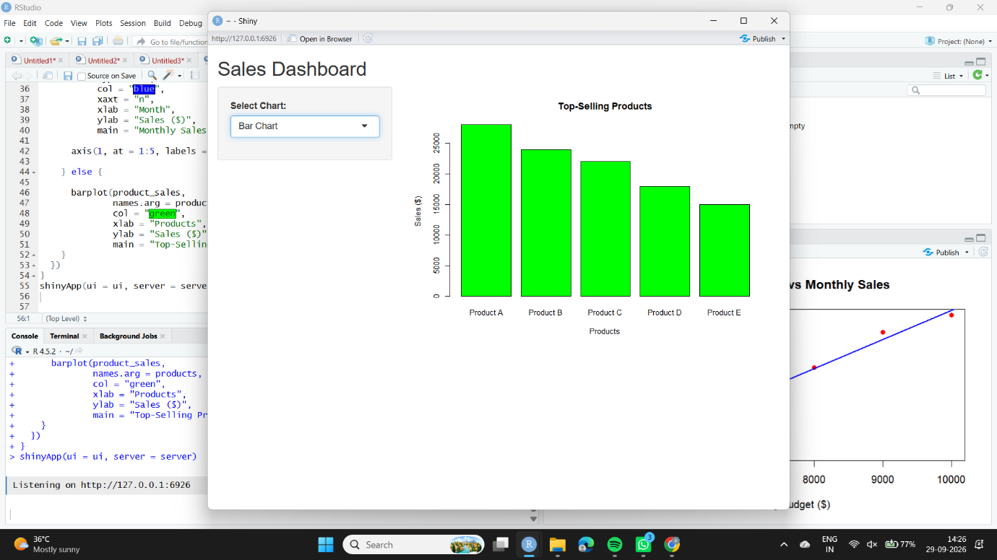
Observation
The histogram represents the distribution of customer ages. The customers in the dataset have ages ranging from 25 to 40 years.
3. Aim
To create a pie chart in R to represent the overall distribution of customer satisfaction scores.
Algorithm
- Create a vector containing satisfaction scores.
- Count the frequency of each score using table().
- Use the pie() function to create the chart.
- Add labels and a suitable title.
- Display the pie chart.
R Code
# Satisfaction Scores
satisfaction <- c(4, 5, 3, 4, 5)
# Count Satisfaction Scores
score_count <- table(satisfaction)
# Pie Chart
pie(score_count,
labels = paste("Score", names(score_count)),
main = "Customer Satisfaction Scores")
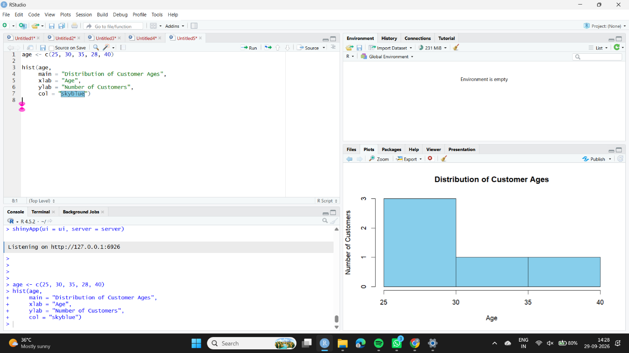
Observation
The pie chart shows that scores 4 and 5 each occur twice, while score 3 occurs once. Therefore, most customers have given relatively high satisfaction scores.
Aim
To create a stacked bar chart in R to visualize the distribution of customer satisfaction scores across different age groups.
Algorithm
- Create vectors for customer ages and satisfaction scores.
- Divide customers into age groups.
- Create a frequency table using table().
- Use barplot() to create a stacked bar chart.
- Add labels, title, and legend.
R Code
# Customer Data
age <- c(25, 30, 35, 28, 40)
satisfaction <- c(4, 5, 3, 4, 5)

# Create Age Groups
age_group <- cut(age,
breaks = c(19, 29, 39, 50),
labels = c("20-29", "30-39", "40+"))

# Create Frequency Table
data <- table(age_group, satisfaction)

# Stacked Bar Chart
barplot(data,
beside = FALSE,
main = "Customer Satisfaction by Age Group",
xlab = "Age Group",
ylab = "Number of Customers",
col = rainbow(3),
legend.text = TRUE)
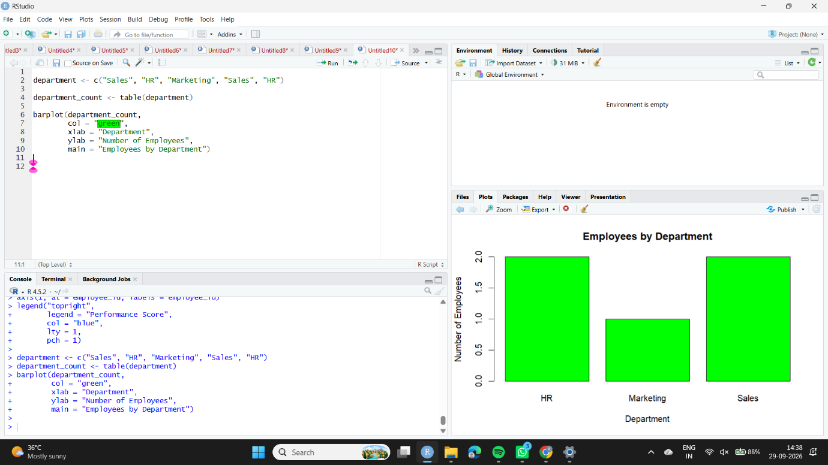
Observation
The stacked bar chart shows the satisfaction scores within each age group. The 20–29 age group contains two customers with a satisfaction score of 4, while the other age groups contain individual customers with different satisfaction scores.
Aim
To create a word cloud in R from open-ended customer feedback and identify frequently occurring words and customer sentiments.
Short Algorithm
- Create a collection of customer feedback statements.
- Load the tm and wordcloud packages.
- Create a text corpus.
- Convert the text to lowercase and remove punctuation and stop words.
- Calculate word frequencies.
- Generate the word cloud based on word frequency.
R Code
# Install packages if required
# install.packages("tm")
# install.packages("wordcloud")
library(tm)
library(wordcloud)
# Customer Feedback
feedback <- c(
"Excellent service and friendly staff",
"Very satisfied with the service",
"Good customer support",
"Excellent quality and fast service",
"Friendly staff and good experience"
)

# Create Corpus
corpus <- Corpus(VectorSource(feedback))

# Convert to Lowercase
corpus <- tm_map(corpus, content_transformer(tolower))

# Remove Punctuation
corpus <- tm_map(corpus, removePunctuation)

# Remove Stop Words
corpus <- tm_map(corpus, removeWords, stopwords("english"))

# Create Term-Document Matrix
tdm <- TermDocumentMatrix(corpus)

# Convert to Matrix
matrix <- as.matrix(tdm)

# Calculate Word Frequency
word_freq <- sort(rowSums(matrix), decreasing = TRUE)

# Create Word Cloud
wordcloud(names(word_freq),
word_freq,
min.freq = 1,
random.order = FALSE,
main = "Customer Feedback Word Cloud")
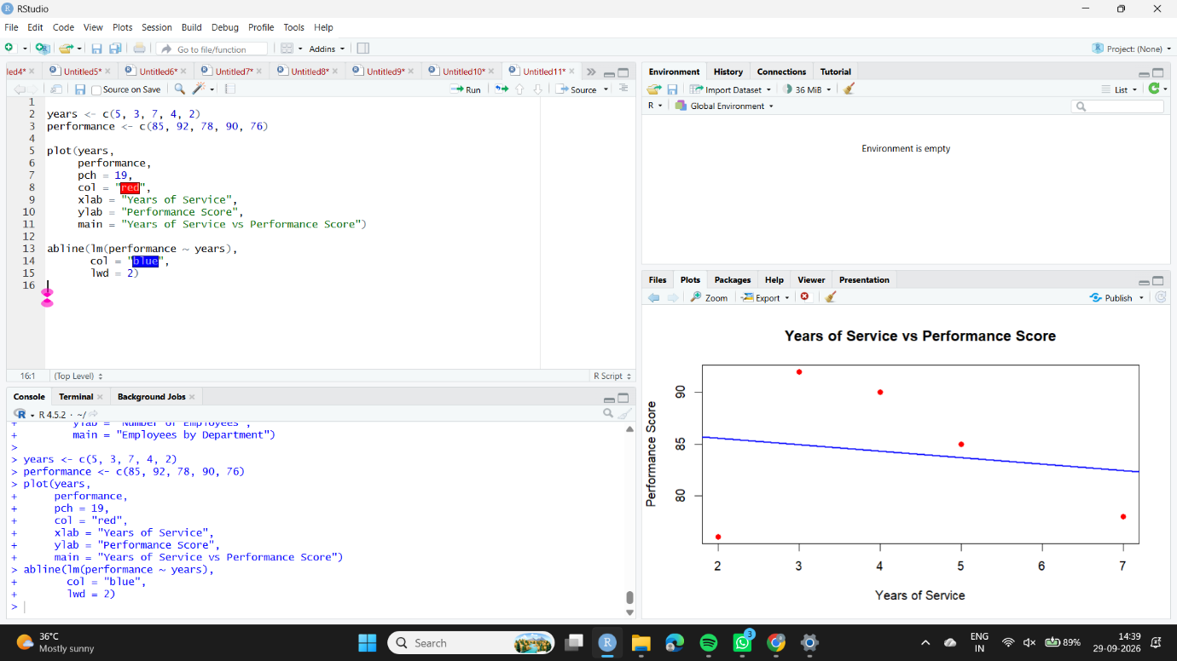
Observation
The word cloud displays frequently used words from customer feedback. Words such as excellent, friendly, good, service, and satisfied appear frequently, indicating generally positive customer feedback.

